X2go client can be downloaded from ( it is installed on the morgan state cloud – Bear general VM)

[Download link](https://wiki.x2go.org/doku.php/download:start)

Instructions for setting X2Go for your account

1. Start up the X2Go client
2. Name the Session ( a good idea is to name the session the name of the server)

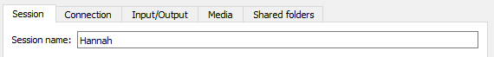

1. Enter the host IP and Login ( username), leave the SSH as 22

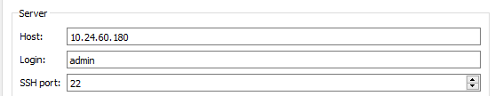

1. Change session type to XFCE

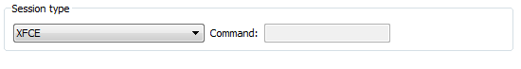

1. Change connection to LAN

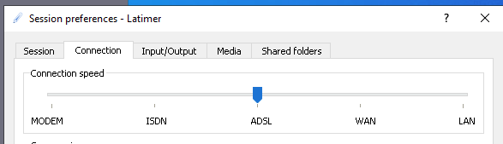

1. You can resize the screen to your optimal resolution

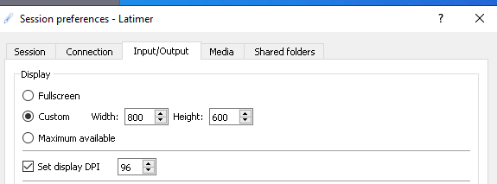

1. Click on OK
2. Click on the server name on the right hand side and enter your password at the prompt.

